**ASSIGNMENT 4**

**1. EC2 Instance Launch Page.**

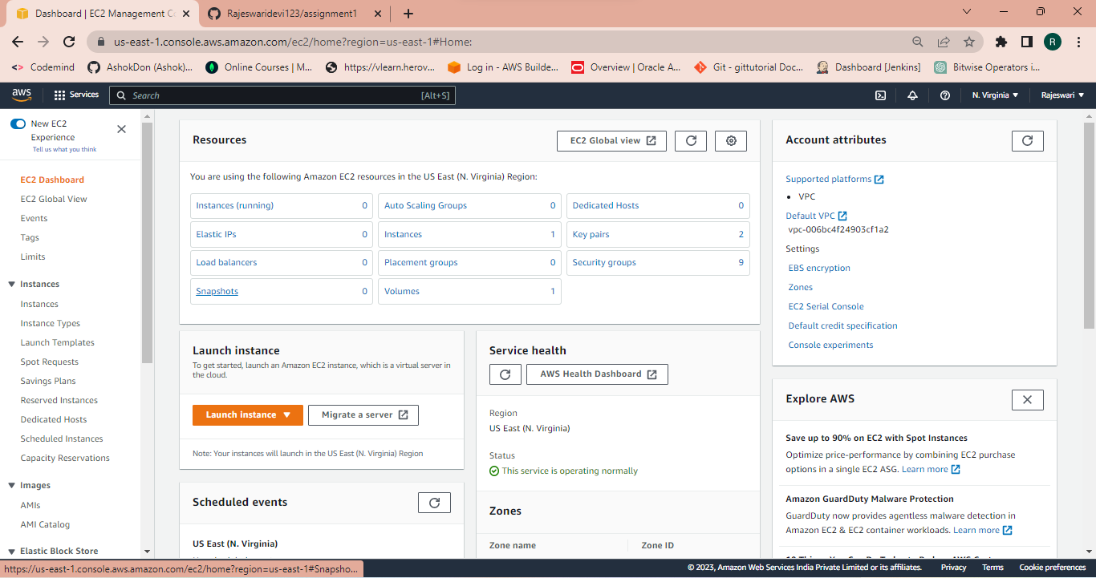

**2. EC2 Name and Tag Creation.**

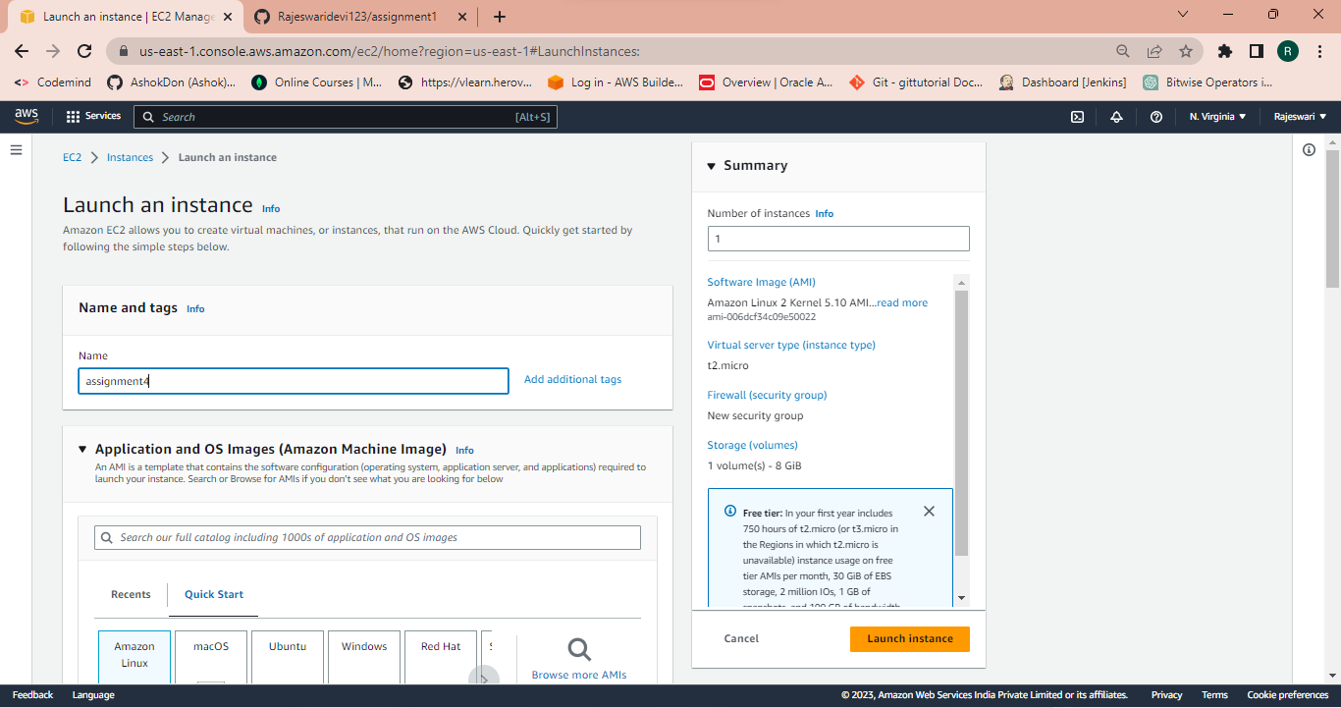

**3. EC2 AMI Selection.**

**4. EC2 Key Pair Creation**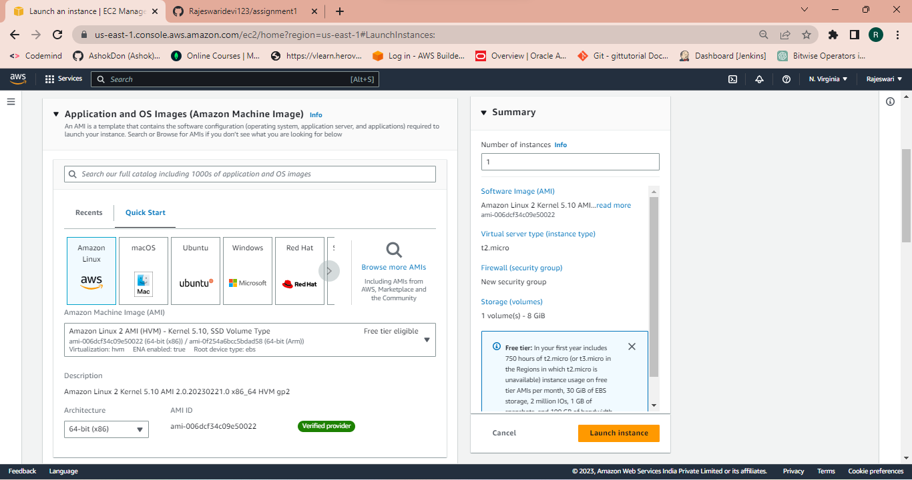

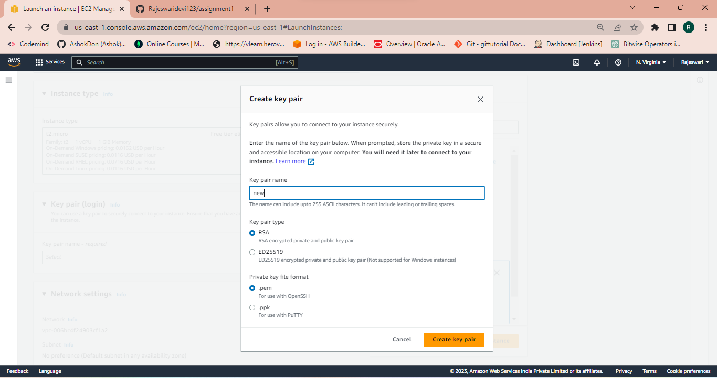

**5. EC2 Security Group Creation ( SSH,HTTP,HTTPS).**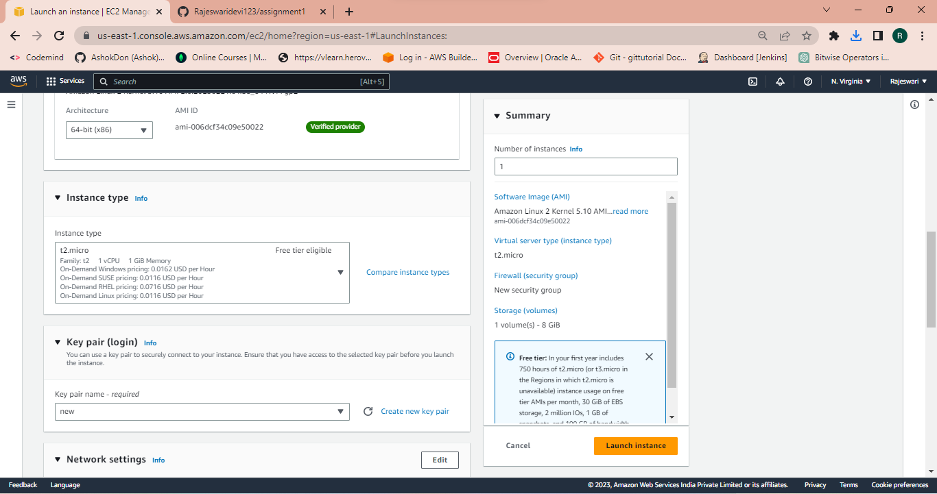

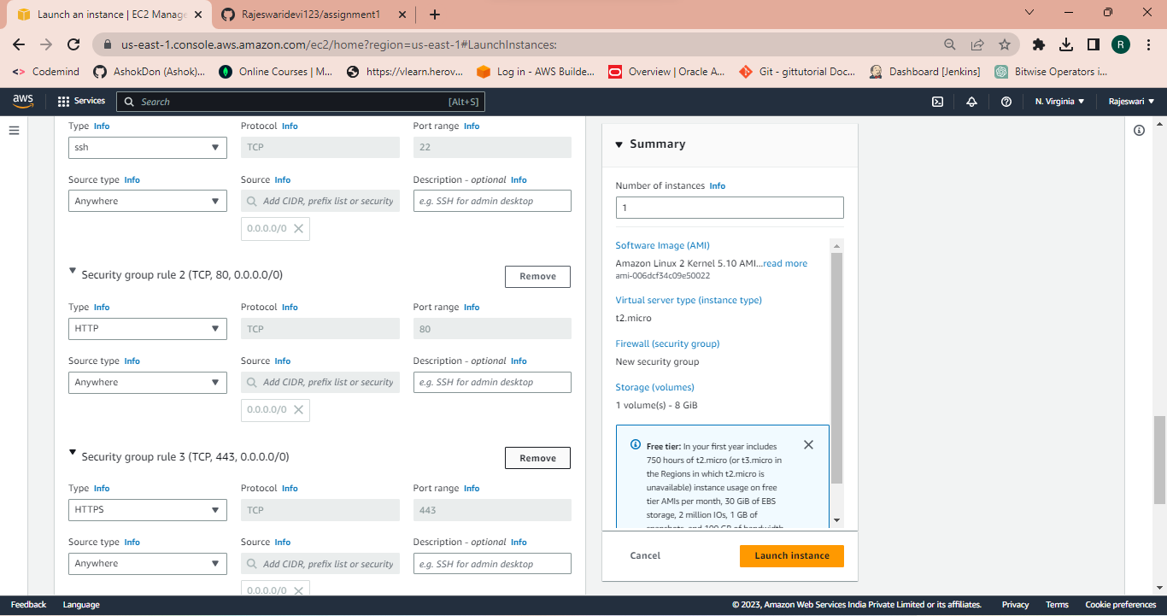

**6. EC2 VPC and Subnet Selection**

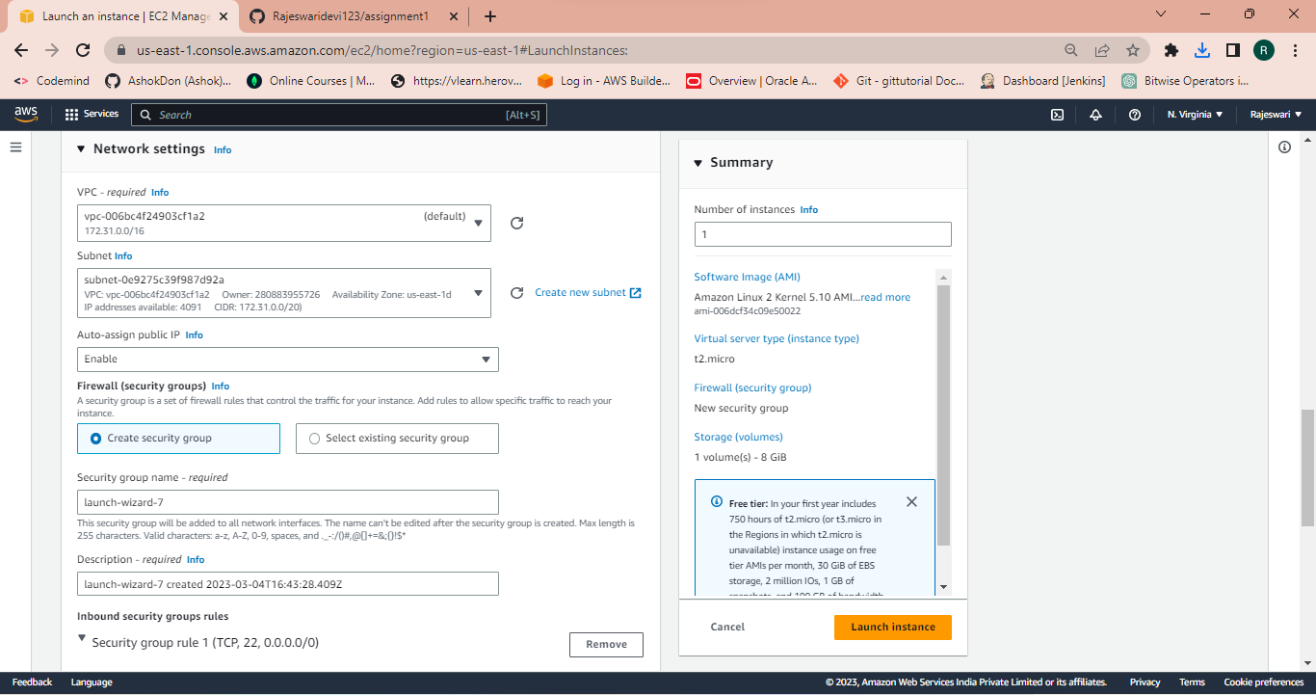

**7. EC2 EBS Volume Selection**

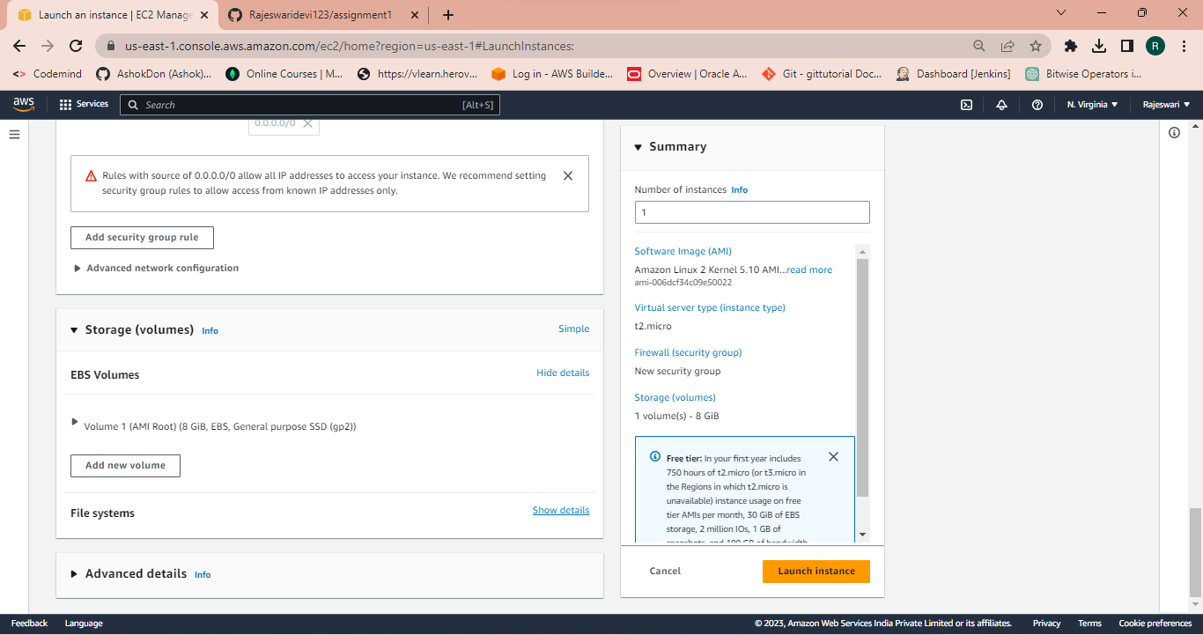

**8. User Data Insertion Page with below command**

**#!/bin/bash**

**yum update -y**

**yum install httpd –y**

**service httpd start**

**chkconfig httpd on**

**IP_ADDR=$(curl** [**http://169.254.169.254/latest/meta-data/public-ipv4**](http://169.254.169.254/latest/meta-data/public-ipv4)**)**

**echo "Manual instance with IP $IP_ADDR" > /var/www/html/index.html**

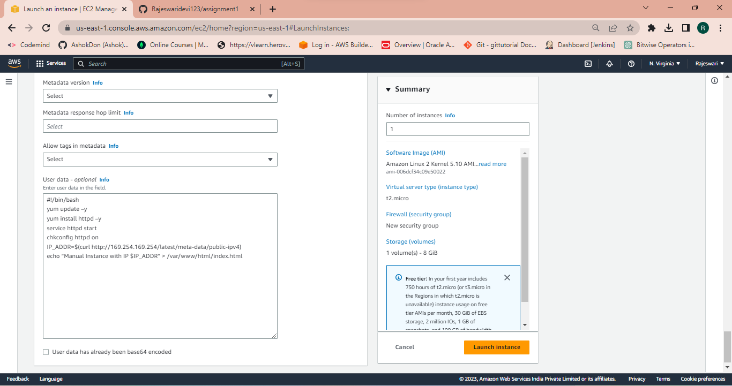

**9. EC2 Launch Logs**

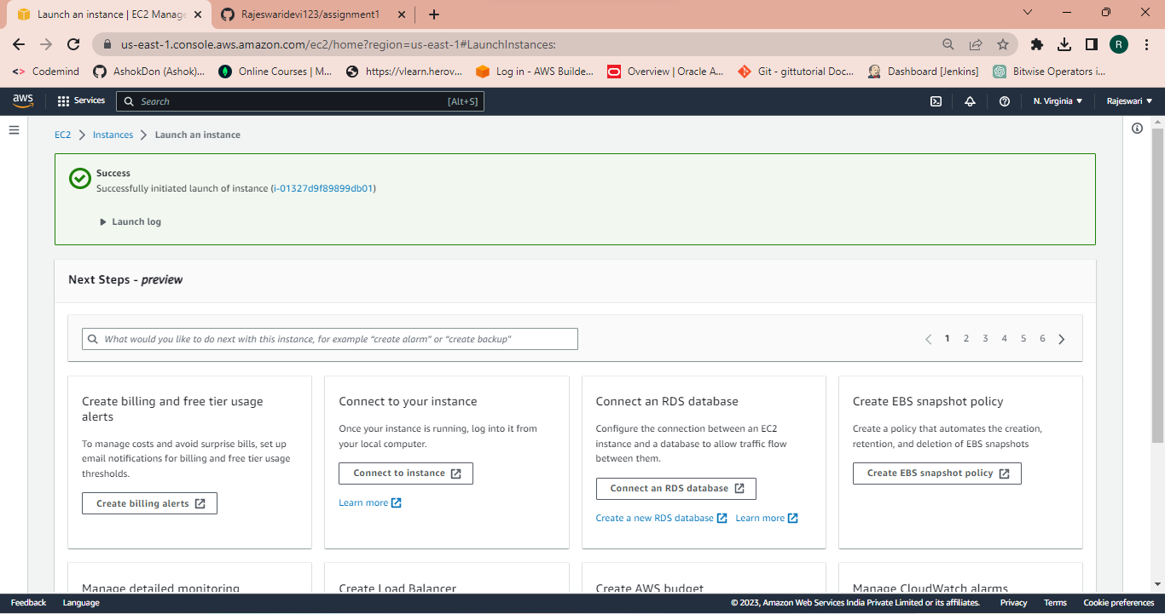

**10. EC2 Instance Running State.**

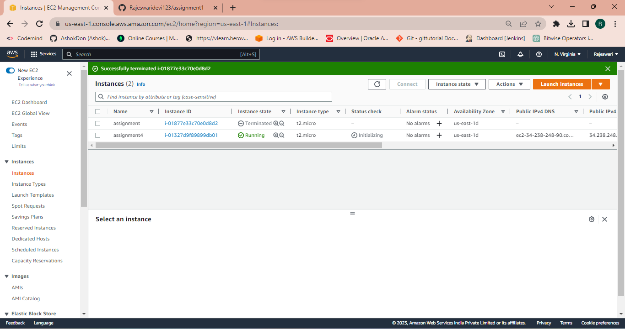

**11. EC2 Summary Page with Public and Private IP.**

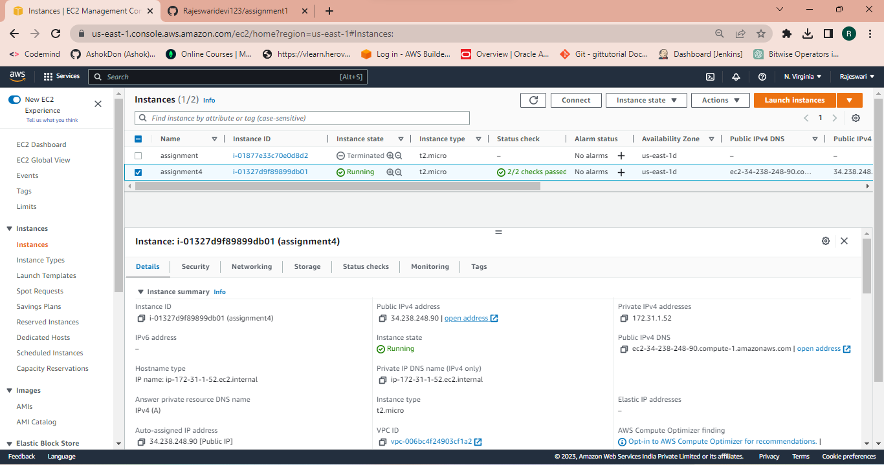

**12. EC2 Instance Monitoring Page.**

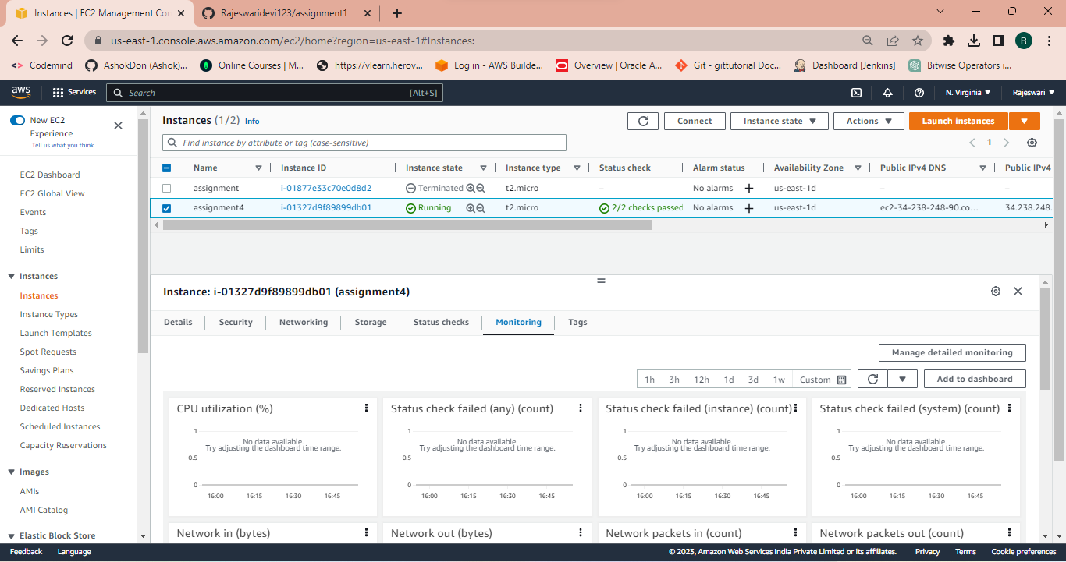

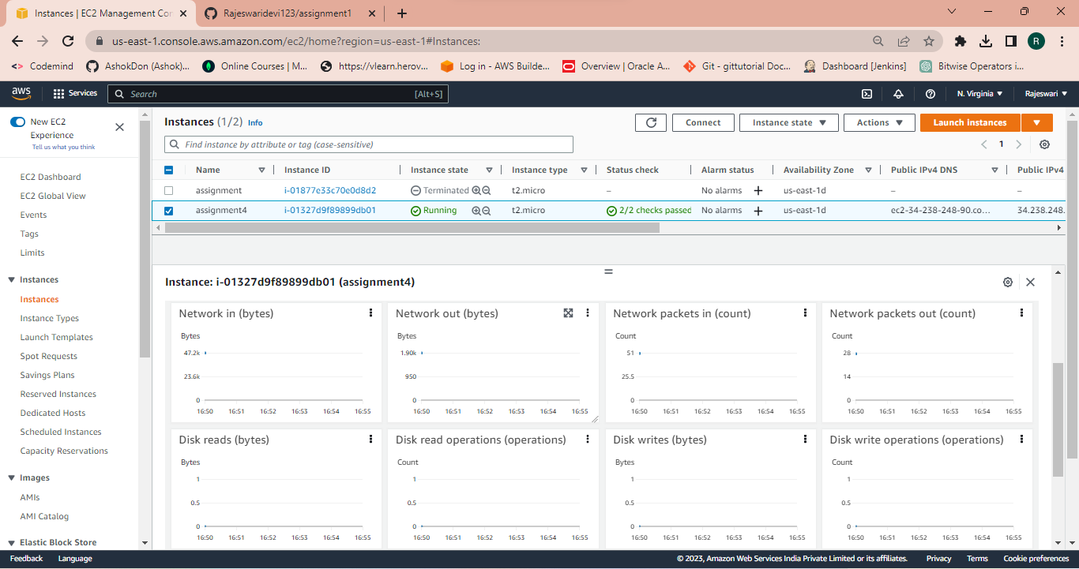

**13. SSH Access of EC2 instance in Local Machine.**

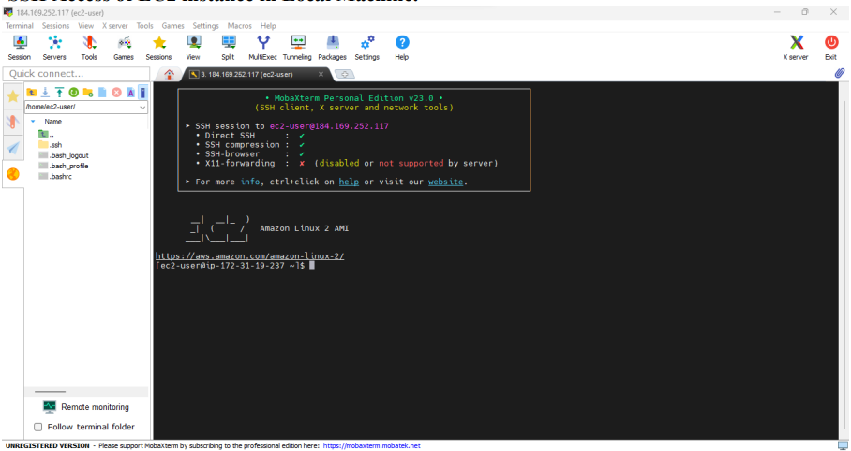

**14. Browsing EC2 instance in the Browser Local Machine.**

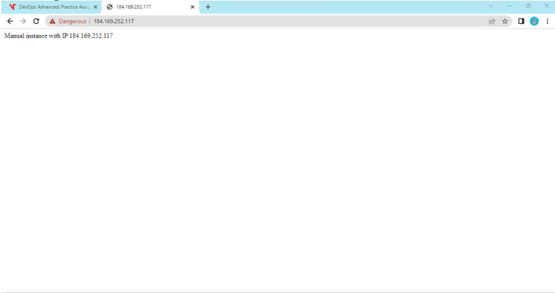

**15. Terminating the Resource.**

